

Practices for Secure Software Report

Table of Contents
Document Revision History 3
Client 3
Instructions 3
Developer 4
1. Algorithm Cipher 4
2. Certificate Generation 4
3. Deploy Cipher 4
4. Secure Communications 4
5. Secondary Testing 4
6. Functional Testing 4
7. Summary 4
8. Industry Standard Best Practices 4

Document Revision History

Version | Date | Author | Comments
1.0 | [Date] | [Your Name]

Client



Instructions

Submit this completed practices for secure software report. Replace the bracketed text with the relevant information. You must document your process for writing secure communications and refactoring code that complies with software security testing protocols.

- Respond to the steps outlined below and include your findings.
- Respond using your own words. You may also choose to include images or supporting materials. If you include them, make certain to insert them in all the relevant locations in the document.
- Refer to the Project Two Guidelines and Rubric for more detailed instructions about each section of the template.

Developer
[Kristi Huggins]

Algorithm Cipher

I recommend SHA-256 for Artemis Financial because the company needs a way to verify that data hasn't been changed while being transferred through the web application. SHA-256 is a hashing algorithm that creates a unique 256-bit checksum for data. If the data is modified in any way, the checksum changes, making it easy to detect tampering.

To secure communications, the application should also use SSL/TLS certificates. TLS uses asymmetric encryption, which relies on a public and private key pair, along with randomly generated keys to establish a secure connection. Once connected, symmetric encryption is used because it is faster and more efficient for transferring data.

As security threats have evolved, encryption and hashing algorithms have become stronger and more reliable. Today, SHA-256 remains a trusted industry standard for verifying data integrity and supporting secure communications. Because Artemis Financial specifically needs a checksum verification step, SHA-256 is the most appropriate choice for this application.

Certificate Generation
Insert a screenshot below of the CER file.

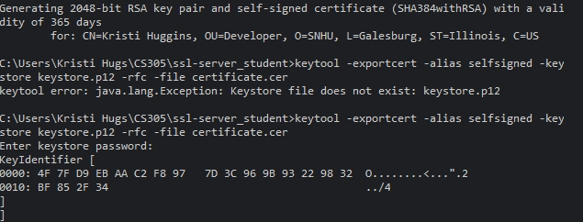

Deploy Cipher
Insert a screenshot below of the checksum verification.

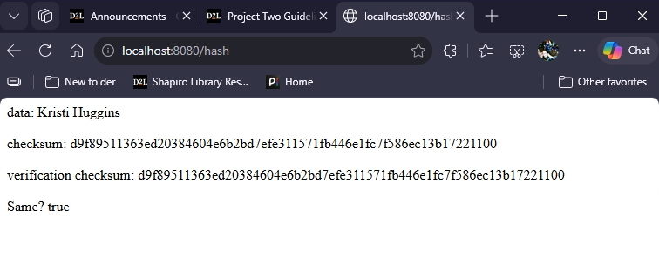

Secure Communications
Insert a screenshot below of the web browser that shows a secure webpage.
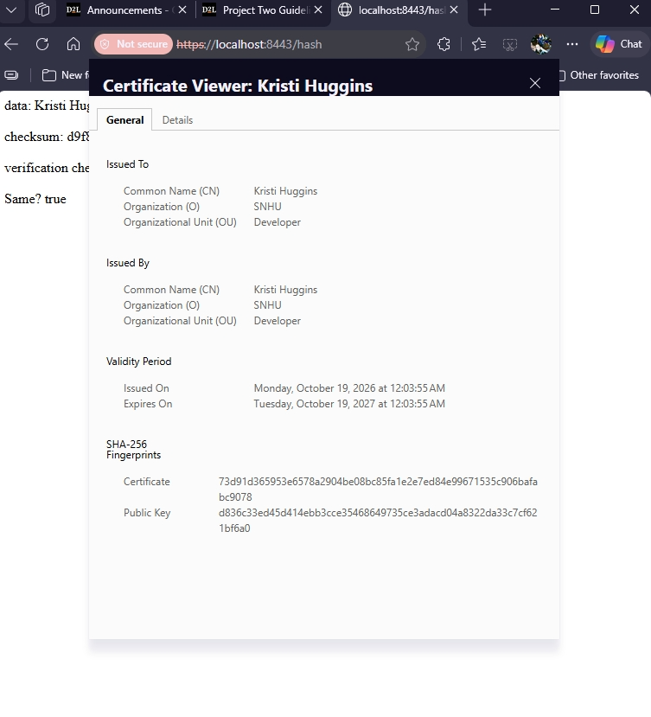

Secondary Testing
Insert screenshots below of the refactored code executed without errors and the dependency-check report.

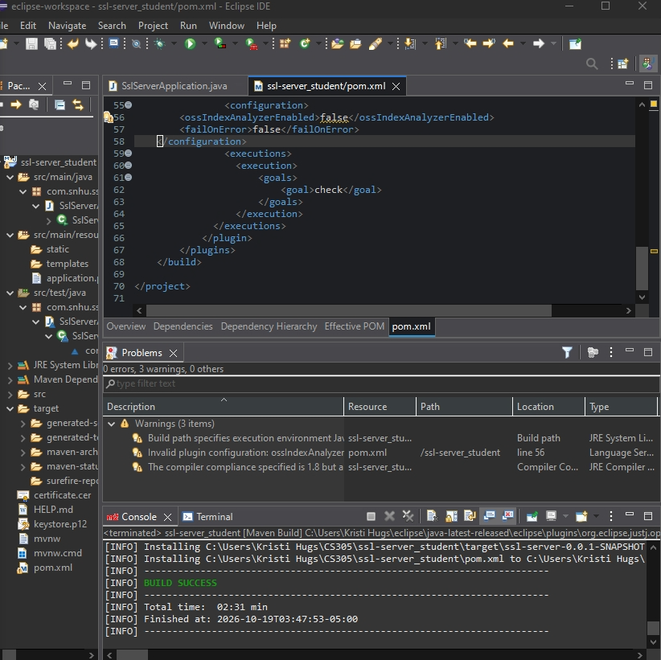
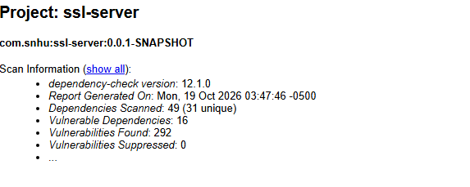

Functional Testing
Insert a screenshot below of the refactored code executed without errors.

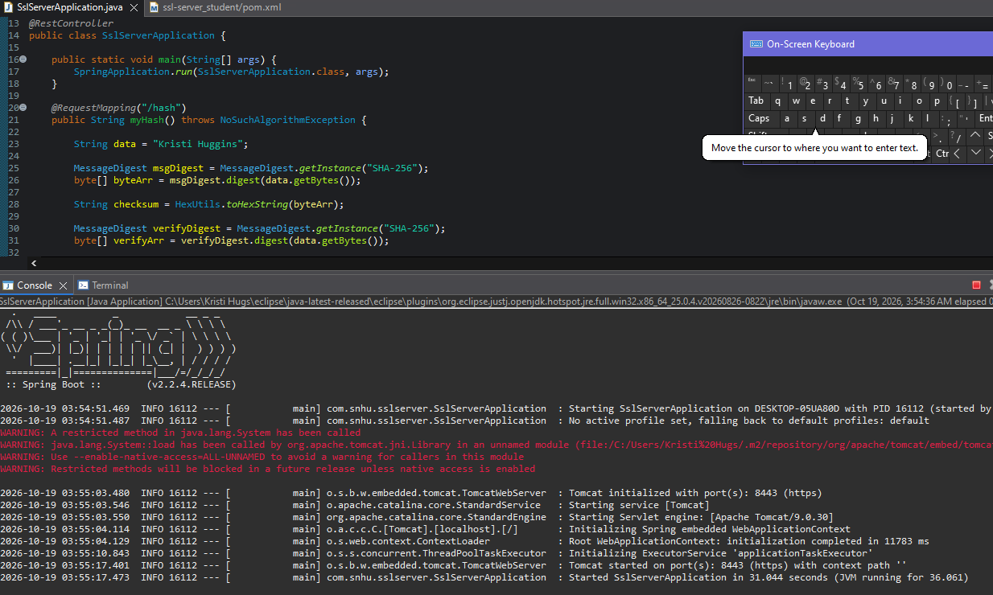

Summary

I refactored the application by adding a SHA-256 checksum feature and enabling HTTPS with a self-signed SSL certificate. These changes improved data integrity by allowing transmitted data to be verified and secured communication between the client and server through encryption. The main security areas addressed were data integrity and secure communications.

To add layers of security, I implemented checksum verification, enabled SSL/TLS encryption, and performed both functional testing and dependency scanning to verify the application operated securely after the changes were made.

Industry Standard Best Practices

I followed industry-standard security practices by using SHA-256 hashing for data verification, SSL/TLS for encrypted communications, and OWASP Dependency-Check to identify known vulnerabilities. These steps helped maintain existing security while adding new protections.

Applying secure coding best practices helps protect sensitive financial information, reduce security risks, and improve trust in the application. For Artemis Financial, these improvements help safeguard client data and support secure communications.

